5 Themes of Geography Quiz

- Geography is the study of _________________________________.

- Name the 5 themes of geography

- Find A) 40 degrees South and 140 degrees East, B) 20 degrees north and 100 degrees west
Where are you each time?

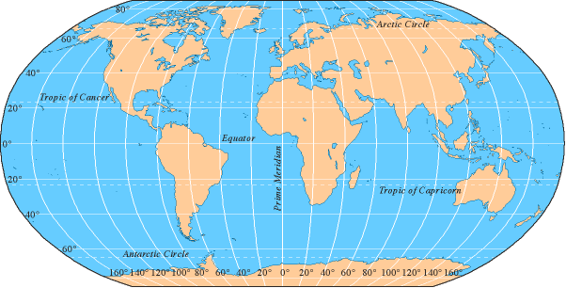

4. What kind of location explains where a place is by describing places near it?
a. Absolute
b. Exact
c. Relative
d. Descriptive

5. There are two ways to describe the location-Physical and Human. Explain the difference.

6. Give an example of how people affect their environment

7. What three things do geographers concern themselves with movement?

8. Give a positive example of movement and a negative example of movement

9. Which theme is used to make comparisons?

10. Which line is a line of latitude-Equator or Prime Meridian?

